PRESS RELEASE
AZL Aachen GmbH in cooperation with Institute of Plastics Processing (IKV) in Industry and the Skilled Crafts at RWTH Aachen University

Aachen/Germany
May 9, 2017

Call for Partners: Joint Market and Technology Study on High-Performance SMC
In June 2017, AZL Aachen GmbH in cooperation with the Institute of Plastics Processing (IKV) at RWTH Aachen University will start a Joint Market and Technology Study on High-Performance SMC with the aim to evaluate the potential of a next generation of SMC in industrial applications. Companies along the entire SMC value chain as well as those interested in the SMC market are invited to join.
SMC (Sheet Molding Compound) is since many years a proven and first choice solution for replacing metal parts. The drive to further weight savings and significant reduction in CO₂ emissions requires a next generation of High-Performance SMC (HP-SMC) with short and continuous fiber-reinforced systems using both carbon and glass fibers with customized resin compounds. HP-SMC offers huge potentials to realize parts with high performance at clearly reduced costs compared to conventional continuous fiber reinforced parts. In comparison to other materials, HP-SMC is determined by a high number of interdependencies between material and processes which are both challenge and potential.
The Joint Market and Technology Study on High-Performance SMC (www.lightweight-production.com/go/hp-smc-study) of AZL and IKV aims at broadening the understanding of these interdependencies by providing in-depth knowledge on SMC applications and technologies, key challenges, and technological solutions for establishing High-Performance SMC. This will serve as basis for the elaboration of design guidelines, a target-oriented development and to open up new business opportunities.
Study inspired by Workgroup of international AZL Partner Network
Scope and content of the study have been developed in close collaboration with the industrial AZL Workgroup which was established in an initial workshop in 2016 with more than 60 participants from the industry, including several automotive OEMs such as Audi, BMW, Ford, Hyundai, MAN, Toyota and Volkswagen (www.lightweight-production.com/azl-establishes-workgroup-high-performance-smc). During several meetings, the industrial workgroup defined different joint research and development initiatives to build a toolbox for HP-SMC, one of the being the Joint Market and Technology Study on High-Performance SMC.
The 12-months study is designed as a joint study involving players along the entire value chain. This approach allows participants to benefit from the knowledge of all study partners and experts who are involved in the project. Study participants will be a direct part of the study and will be able to influence the progress according to their specific demands.
Use cases and value chains, FMEA, new scenarios to solve key challenges and market overview
Based on the state of the art of SMC technology, use cases and value chains with special consideration of HP-SMC, a Failure Mode and Effects Analysis (FMEA) for specific production and application scenarios will be conducted to evaluate existing technologies currently applied and their readiness level. Established best practice solutions will be demonstrated as well. Remaining key challenges and their interactions along the value chain will be concluded to define fields of action for targeted development for High-Performance SMC. Based on the detailed technology studies, new scenarios to solve the key challenges will be developed to provide necessary information to support product and service development of the participating companies. AZL and IKV will evaluate and determine which products, materials and technologies from other technological areas provide potential solutions and will give an overview of the markets, value chains and providers for such next-level solutions as basis for new business opportunities. The study will be a basis for joint developments to establish HP-SMC in broad industrial applications.
The Joint Market and Technology Study on High-Performance SMC is open for all companies along the SMC value chain as well as companies which want to enter the SMC market. AZL partner companies and members of the IKV association of sponsors can participate at a reduced fee. The finalization of the consortium and information on the content and approach of the study will be conducted in an information event during the 3rd Workgroup Meeting (www.lightweight-production.com/go/smc-information-event) of the High-Performance SMC Workgroup on May 31, 2017 in Aachen. Information event and Workgroup Meeting are open for all interested companies. The deadline for participation in the study is June 15, 2017.

www.ikv-aachen.de
www.azl.rwth-aachen.de
www.lightweight-production.com

Pictures
Download of high-resolution pictures:
http://azl-aachen-gmbh.de/wp-content/uploads/2017/05/Pictures_HP-SMC_AZL.zip

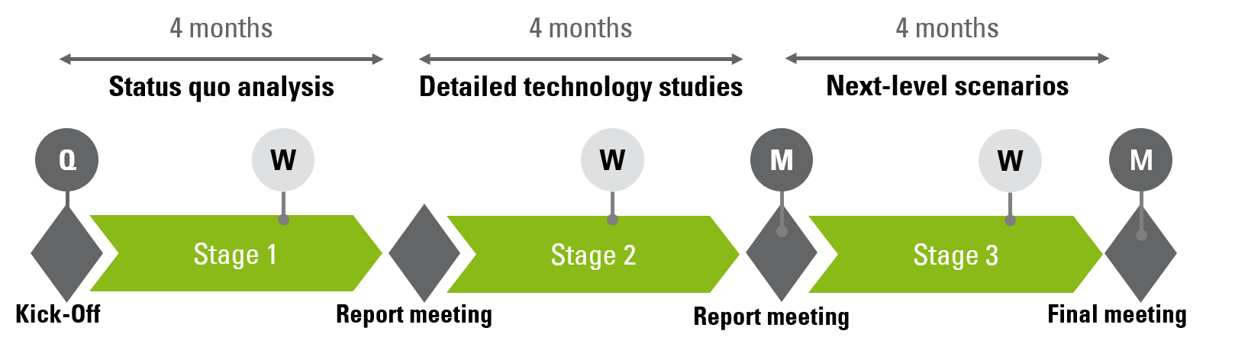
Picture 1: The 12-months study is designed as a joint study involving players along the entire value chain. Participants will benefit from the knowledge of all study partners and experts who are involved in the project. Copyright: AZL Aachen GmbH

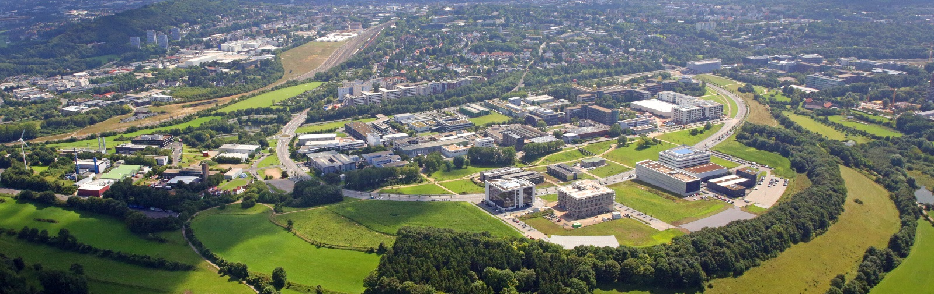
Picture 2: Competences and hardware along the entire SMC process chain are represented at the RWTH Aachen Campus.
Copyright: Campus GmbH/ Steindl

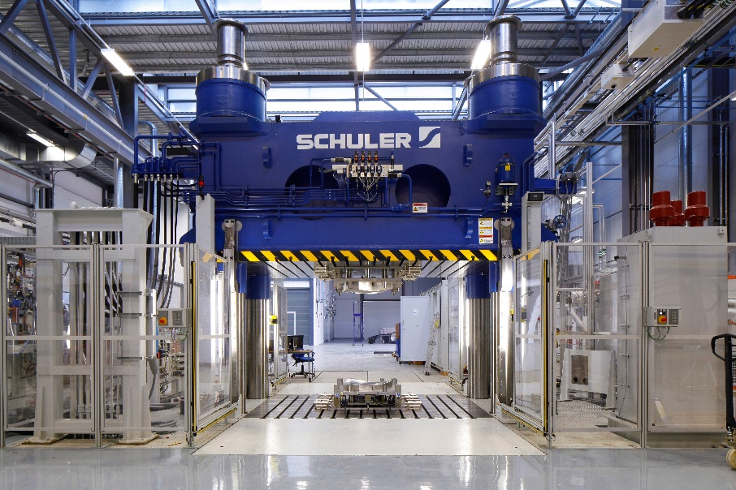
Picture 3: Large-scale industrial manufacturing equipment for SMC is also available in AZL´s new research facility at RWTH Aachen Campus. Copyright: Schuler Pressen GmbH.

About AZL:
RWTH Aachen University is one of the worldwide leading universities in the field of production technology. The Aachen Center for integrative Lightweight Production (AZL) of RWTH Aachen consolidates the lightweight expertise of eight partner institutes with 750 scientists on the RWTH Aachen Campus. The AZL builds an international partner network between these institutes and more than 70 international companies involved in lightweight production.
For this, AZL consists of two separate entities: The AZL of RWTH Aachen University addresses the transformation of lightweight design in mass production with basic research and development of lightweight products, materials, production processes and systems with access to the latest full-scale machines and automation systems. As a service provider partnering with companies in the field of lightweight production technology, AZL Aachen GmbH provides industrial services in the areas of engineering, consultancy and project management, networking and business development. With the AZL Partnership, the AZL Aachen GmbH enables the close cooperation between the lightweight industry and the research institutes of RWTH Aachen Campus along the whole value chain. The AZL Partner Network consists of more than 80 industrial partners representing the entire lightweight production value chain from the raw material producer, over molders, manufacturing equipment suppliers, Tier 1 and Tier 2 to OEMs, from SMEs to large multinational corporations, from Germany to Mexico, China or Japan, from 21 different countries in total.

About IKV:
IKV, the Institute of Plastics Processing at RWTH Aachen University, is Europe-wide the leading research and education institute engaged in the field of plastics processing enjoying outstanding reputation. More than 300 staff are employed in finding solutions to problems connected with processing, materials technology and part design in the plastics and rubber industries. IKV's close contacts with industry and science, together with its outstanding facilities, enable cutting-edge research in plastics technology and ensure that students benefit from a comprehensive, practically oriented course of study. Plastics engineering graduates from IKV are thus sought-after experts in industry. In organisational terms, IKV is divided up into the four specialist departments of Injection Moulding, Extrusion and Rubber Technology, Part Design and Materials Technology, and Composites and Polyurethane Technology. The institute also takes in the Centre for Analysis and Testing of Plastics, and the Training and Further Education department. IKV is run by an Association of Sponsors, which currently has a membership of about 290 plastics companies from all over the world. Univ.-Prof. Dr.-Ing. Christian Hopmann is Head of the Institute and Managing Director of the Association of Sponsors. He also holds the Chair of Plastics Processing at the Faculty of Mechanical Engineering at RWTH Aachen University.

